**Gait Recognition Research Using Machine Learning for Covered Body Attire**

*By*

Muhammad Zakaria Masood  
BSIT51F20S048

Zill E Haseeb  
BSIT51F20S009

Session 2020-2024

Supervised by

Mr. Farooq Javaid

**Department of Information Technology  
University of Sargodha**

**Table of Contents**

1 Introduction 4

1.1 Purpose of Document 4

1.2 Project Overview 4

1.3 Scope 5

1.4 Problem Domain 5

1.5 Research Problem Statement 5

2 Literature Review 7

2.1 Analysis Summary of research items 8

3 Proposed Approach 8

3.1 Video Dataset Creation 9

3.2 Video Extraction Frame 10

3.3 Landmark extraction and frame processing 10

3.4 Data Sorting and Splitting 10

3.5 Model Training and Evaluation 11

3.5.1 Classifier using Decision Trees: 11

3.5.2 The Random Forest Classifier 11

3.6 Evaluation Metrics and Confusion Metrics 12

3.6.1 Findings from the Decision Tree Classifier: 12

3.6.2 Findings from the Random Forest Classifier: 12

4 Experiments and Results 13

4.1 Experimental Setup 13

4.1.1 Dataset Preparation 13

4.1.2 Data Processing 13

4.1.3 Model Training 14

4.1.4 Evaluation Metrics 14

4.2 Results 14

4.3 Analysis 15

4.3.1 Graphical Representations of Metrics 15

4.4 Discussion 18

5 Bibliography 18

**List of Figures**

Figure 1: Dataset frames 4

Figure 2: Decision Tree Working 11

Figure 3: Random Forest Classifier Structure 12

Figure 4: Decision Tree Metrics 16

Figure 5: Decision Tree Confusion Metric 16

Figure 6: Random Forest Metrices 17

Figure 7: Random Forest Confusion Metric 17

**List of Tables**

Table 1: Analysis Summary of Research Items 8

Table 2:Decicion Tree Results 14

Table 3:Random Forest Results 14

# **Introduction**

## **Purpose of Document**

This paper presents the research that was done to create a machine learning-based gait identification system for people who cover up their bodies. The goal of the study is to overcome the shortcomings of conventional facial recognition systems, which fail to identify faces of people whose faces are hidden by apparel. In order to develop a reliable and accurate biometric identification system based on gait patterns, this research investigates and applies machine learning techniques, particularly Decision Trees and Random Forest classifiers.

## **Project Overview**

The development and assessment of machine learning models for gait recognition is the focus of this research, which aims to address situations in which people are covered up. The following essential steps are part of the research:

**Video Dataset Creation:**The process of creating a video dataset involves filming people walking from various angles in order to collect detailed gait patterns.

**Video Frames Extraction:**   
To create a strong dataset, individual frames are extracted from the recorded videos.

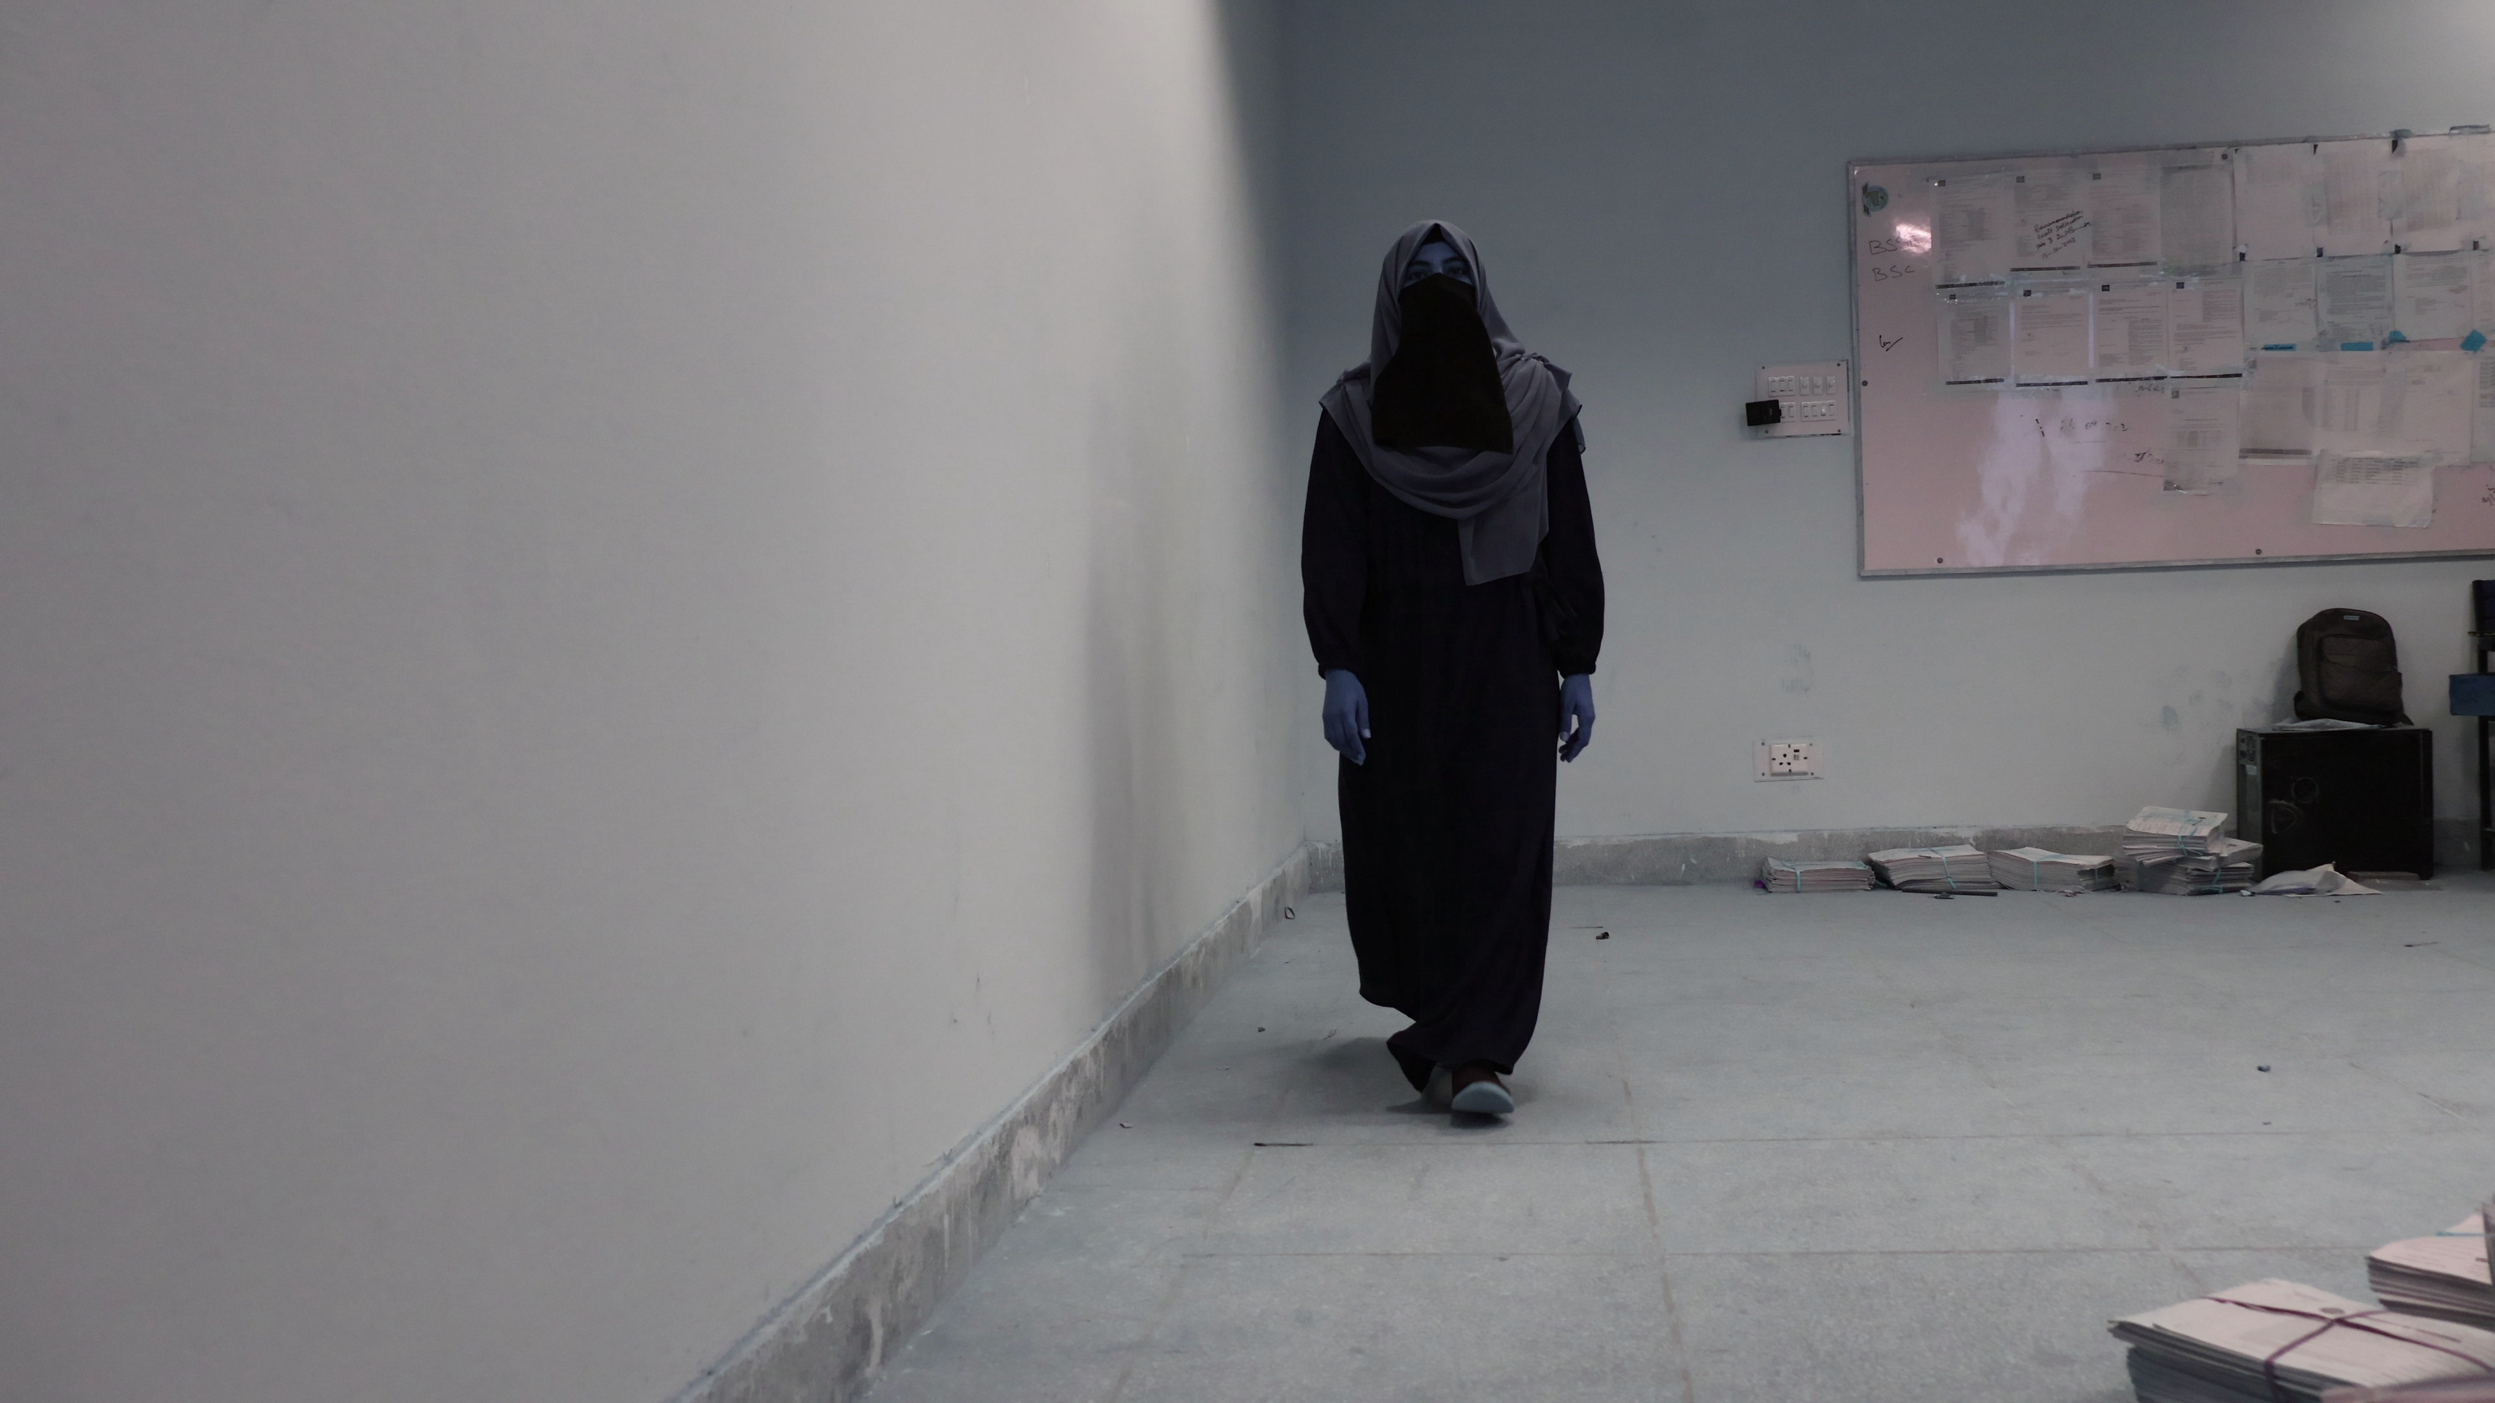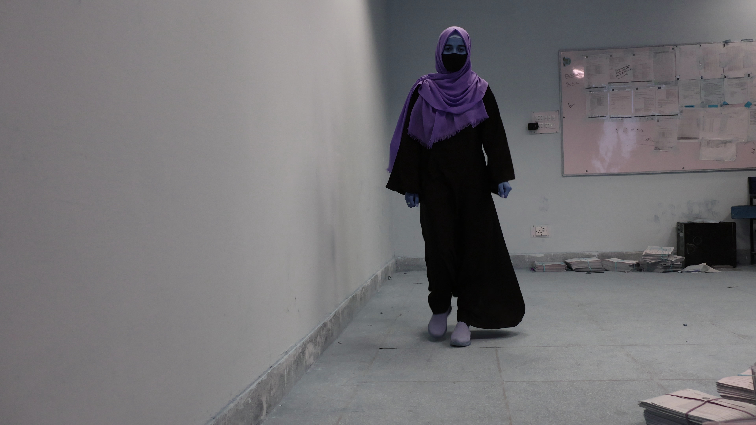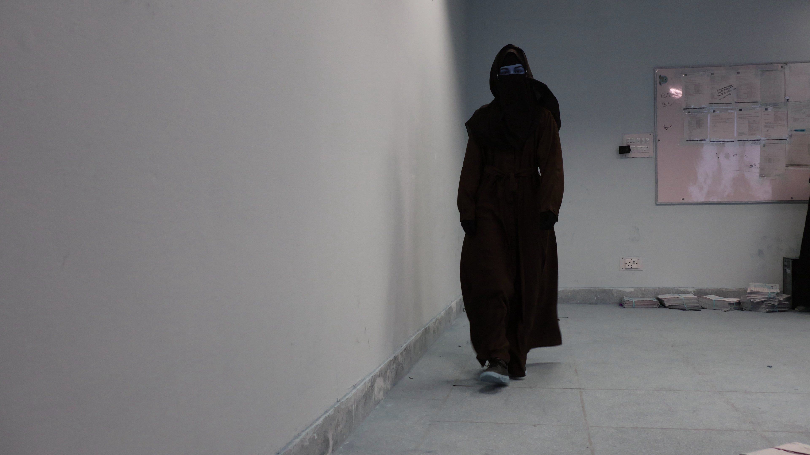

Figure 1: Dataset frames

**Frame processing and Landmark Extraction:**  
Using the Mediapipe library, identify important body components to study gait patterns and extract body landmarks from frames.

**Data Sorting and Splitting:** Using stratified sampling, the dataset is preprocessed and split into training and testing sets.

**Model Training and Evaluation:** Using accuracy, precision, recall, F1 score, and confusion matrices, Decision Tree and Random Forest classifiers are trained on the dataset.

The results show that the Random Forest classifier achieves almost perfect accuracy on the testing set, performing noticeably better than the Decision Tree classifier.

## **Scope**

This project's scope includes the creation and evaluation of machine learning models targeted especially for the gait recognition of people with covered bodies. The study comprises:

* Complete video recording taken from multiple angles to guarantee a variety of gait pattern data.
* Body landmarks are used in the extraction and processing of video frames to produce feature vectors. Application and evaluation of Random Forest and Decision Tree classifiers to identify the best model.
* A number of metrics, including accuracy, precision, recall, and F1 score, are used to evaluate the performance of the model.
* Results are analyzed and discussed to show the advantages and disadvantages of each model.

The focus is on fine-tuning Decision Tree and Random Forest classifiers for precise gait recognition, with a restricted scope**.**

## **Problem Domain**

The field or area of interest that the research focuses on is defined in this section. It demonstrates the particular difficulties, problems, or gaps in this field, giving the following research background.  
The creation and use of machine learning-based gait detection technologies, particularly for people who wear clothing that covers their bodies, is the research's issue area. Since people wearing such clothing frequently cannot be identified by traditional facial recognition systems, it is critical to investigate other biometric techniques such as gait recognition. The goal of this study is to close this gap by creating dependable and accurate gait recognition systems.

## **Research Problem Statement**

This is where the specific issue or query that the study seeks to answer is stated. It makes clear the knowledge or practice gap that the study aims to address and helps the reader comprehend the importance and applicability of the research.  
The requirement for an accurate biometric identification system that can precisely identify people donning covered body apparel is the research issue this study attempts to solve. Because existing face recognition systems rely on observable facial traits, they are not suitable for this use. The goal of this project is to create and evaluate machine learning algorithms that can recognize people by their gait, therefore resolving a major drawback in biometric identification technology.

# **Literature Review**

In this section, we review significant pieces of literature related to the research topic, summarizing their main findings, methodologies, and conclusions.

Each significant piece of literature related to the research topic is reviewed individually, beginning with (Ramakrishna, 2023). This section summarizes the research, analyzes its strengths and weaknesses, and discusses its relevance to the proposed study, thereby situating the current research within the broader scholarly discourse.

Recent research has emphasized the role that gait recognition plays in biometric identification systems and the need for non-contact techniques to lower the spread of contagious diseases. Convolutional Neural Networks (CNN) are machine learning models that have demonstrated promising results in properly classifying individuals based on their distinct gait patterns.

By addressing the requirement for non-contact biometric devices, this study shows how successful CNNs are in recognizing gaits. However, obstacles including view angles, clothing differences, and intra-class variance brought about by various carrying situations affect identification effectiveness. The robustness of the study in addressing these variances may be strengthened even more.

The findings inform our approach by highlighting the importance of addressing intra-class variation and using CNNs for robust gait recognition. Our research builds on these insights to improve recognition performance for individuals wearing covered attire.

In the field of gait detection, deep learning-based algorithms have become the industry standard. Current developments concentrate on strengthening the model's resistance to changes in gait and using multimodal data to increase accuracy and efficiency. (Akash Pundir, 2023)

The research highlights the benefits of deep learning in managing intricate changes in gait and incorporating data from several sources. Real-time application may be limited by the computationally demanding nature of the integration process.

Our research aims to build on the use of deep learning by integrating multimodal information, focusing on optimizing computational efficiency to facilitate real-time application.

## **Analysis Summary of research items**

The following table summarizes the critical analysis of the research items discussed:

Table 1: Analysis Summary of Research Items

|  |  |  |  |  |
| --- | --- | --- | --- | --- |
| **Research Item** | **Main Findings** | **Strengths** | **Weaknesses** | **Relevance to Proposed Work** |
| (Ramakrishna, 2023) | Significance of CNNs in gait recognition | Effective non-contact method | Challenges with intra-class variation | Highlights need for robust methods in varied conditions |
| (Akash Pundir, 2023) | Deep learning systems for gait identification | Robust to gait variations, integrates multimodal data | Computationally intensive | Guides use of deep learning, focuses on real-time optimization |

# **Proposed Approach**

The approach and theoretical framework suggested to solve the research topic are described in this chapter. The method entails creating a gait recognition system that can reliably detect people wearing covered apparel by utilizing machine learning methods, most especially Decision Tree and Random Forest classifiers. Below is a full explanation of the procedures, techniques, and models that were employed in this study, along with graphical representations for easy comprehension. (Narayan, 2023).

## **Video Dataset Creation**

To create a comprehensive dataset for gait recognition, we recorded videos of women walking from five different angles: front (00 degrees), right diagonal (45 degrees), right side (90 degrees), left diagonal (45 degrees), and left side (90 degrees). This multi-angle approach ensures that the model can recognize gait patterns from various perspectives, making the recognition system more robust. Each significant piece of literature related to the research topic is reviewed individually, beginning with (Ramakrishna, 2023). This section summarizes the research, analyzes its strengths and weaknesses, and discusses its relevance to the proposed study, thereby situating the current research within the broader scholarly discourse.

These days we also hear that gait recognition has been intensively studied due to its crucial role in biometric identification systems and the demand for non-contact approaches to reduce the transmission of contagious diseases. Gait recognition has been well researched using machine learning models, specifically Convolution Neural Networks (CNNs) have shown good promise in correctly classifying subjects according to their unique gait pattern.

This proved CNNs are great in identifying gaits as they cater the need of non-contact biometric modes. Yet, constraints like view points, garment modifications, and intra-class variance ensuing from several carrying scenarios harm recognition performance. Or enhance the fortitude of the study when it comes to these variations.

The main contribution of the results is to indicate that intra-class variability and robustness require incorporating CNNs in such human gait recognition approaches. Based on these, we continue our research to enhance recognition accuracy of the wearers underneath covered attires.

Deep learning algorithms are state of the art in gait detection. Recent advances have focused on increasing robustness of the model against variations in gait and on leveraging multimodal data to enhance performance and efficiency. (Akash Pundir, 2023)

She believes the research demonstrates the power of deep learning in dealing with subtle changes in gait, and in synthesizing disparate data sources. Integration over the full range of samples for each pixel poses a computational bottleneck that will limit real-time application.

Our research aims to build on the use of deep learning by integrating multimodal information, focusing on optimizing computational efficiency to facilitate real-time application.

## **Video Extraction Frame**

At certain intervals, individual frames from the captured movies were retrieved. Through this procedure, frames were captured at a pace that strikes a compromise between the necessity for enough data and not overloading the system with unnecessary information. The frames obtained were stored along with their appropriate arrangement making it simpler to do processing stages later.

## **Landmark extraction and frame processing**

Mediapipe library was used to extract body landmark for all the frames retrieved. Their data includes landmarks, which are points in common between consecutive scans (where these scans overlap) and are landmarks that indicate important locations, such joints and limbs, that are required for looking at patterns of movement of gait. Landmarks needed to be extracted to get each frame in the correct format. Next was to use the Mediapipe posture estimation model to locate key body parts and label them.

## **Data Sorting and Splitting**

After extracting landmarks, we collected a dataset and sorted them corporately & preprocessed to ensure the correctness and consistency. Furthermore, training and test data sets were established such that the proportion of the classes from the training data to the test data was preserved using stratified sampling. This phase is necessary to evaluate on unseen data, how well these machine learning models work and to ensure that the results are statistically fair.

## **Model Training and Evaluation**

The processed dataset was used to train and assess two machine learning models:

### **Classifier using Decision Trees:**

We trained a Decision Tree classifier on the training set and evaluated it on the testing set. Conclusion: Performance assessment- accuracy, precision, recall, F1 score of the model was analyzed.

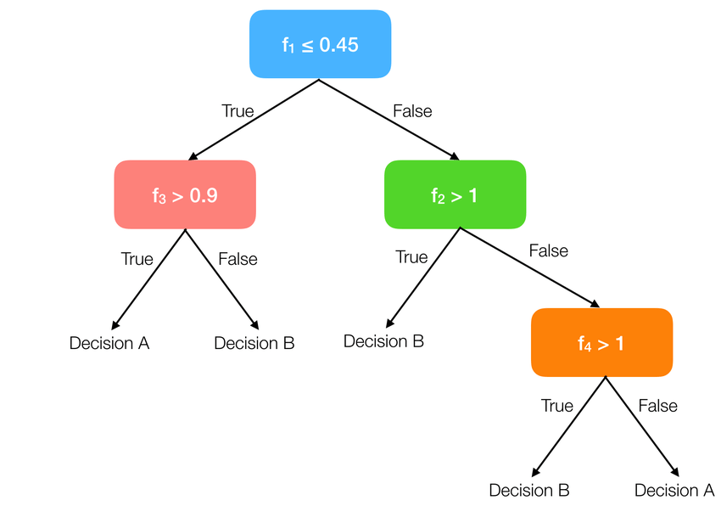

Figure 2: Decision Tree Working

### **The Random Forest Classifier**

Also, the Random Forest classifier was trained and evaluated. With an ensemble based, this model usually performs better than Decision Trees in generalization and risk of overfitting.

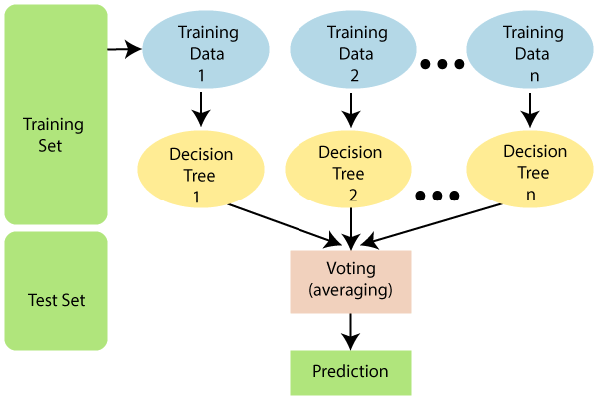

Figure 3: Random Forest Classifier Structure

## **Evaluation Metrics and Confusion Metrics**

For each classifier, the evaluation measures accuracy, precision, recall, and F1 score are calculated. These metrics provide a comprehensive assessment as to how the models perform. In addition, confusion matrices were created to visualize how well the models classified each class. (Ma, 2023)

### **Findings from the Decision Tree Classifier:**

Accuracy: Test 0.86, Train 1.00,  
Precision: Test 0.87, Train 1.00,  
F1 Score: Test 0.86, Train 1.00

### **Findings from the Random Forest Classifier:**

Accuracy: Test 0.98, Train 1.00,

Precision: Test 0.98, Train 1.00,

F1 Score: Test 0.98, Train 1.00

Confusion matrices, which give an indication of precision and reliability of the models in terms of true positive, false positive, true negative, and false negative classifications for both models are presented.

# **Experiments and Results**

Detail of the experiments, experiment set up, and experimental results are illustrated in this chapter. It encompasses a detailed analysis of results, delivered using tabular scores and graphical figures.

## **Experimental Setup**

In this research, the experimental design is performed which is carefully made so that results can be reproducible. Below is the details of the steps and components of the setup:

### **Dataset Preparation**

**Video Recording:** Videos of women walking from five different angles (front, right diagonal, right side, left diagonal, left side) were recorded.

**Frame Extraction:** Frames were extracted from the videos at specific intervals to create a comprehensive dataset.

**Landmark Extraction:** Using Mediapipe, key landmarks (joints and limbs) were extracted from the frames to create feature vectors.

### **Data Processing**

**Sorting and Splitting:**

The dataset was sorted and split into training and testing sets using stratified sampling to maintain class proportions. Python libraries numpy, pandsas are used to process excel files and sort and split data.

**Preprocessing:**   
Data was preprocessed to ensure consistency and accuracy, including normalization and handling missing values.

### **Model Training**

**Algorithms Used:** Decision Tree and Random Forest classifiers were trained on the processed dataset.

**Training Parameters:** Default parameters for both classifiers were used initially, with hyper parameter tuning performed for optimal performance.

### **Evaluation Metrics**

**Metrics Calculated:** Accuracy, precision, recall, and F1 score were calculated for both training and testing sets.

**Confusion Matrices:** Confusion matrices were generated to visualize the classification performance for each class.

## **Results**

Below are the results of the experiments along with tabular notations and graphical plots for better representation.  
  
**Decision Tree Classifier:**

Table 2:Decicion Tree Results

|  |  |  |
| --- | --- | --- |
| **Metric** | **Training Set** | **Testing Set** |
| Accuracy | 1.00 | 0.86 |
| Precision | 1.00 | 0.87 |
| Recall | 1.00 | 0.86 |
| F1 Score | 1.00 | 0.86 |

**Random Forest Classifier:**

Table 3:Random Forest Results

|  |  |  |
| --- | --- | --- |
| **Metric** | **Training Set** | **Testing Set** |
| Accuracy | 1.00 | 0.98 |
| Precision | 1.00 | 0.98 |
| Recall | 1.00 | 0.98 |
| F1 Score | 1.00 | 0.98 |

## **Analysis**

The analysis of the results shows that both classifiers performed well, but the Random Forest classifier outperformed the Decision Tree classifier in all metrics.

**Decision Tree Classifier:**

* Achieved perfect scores on the training set, indicating overfitting.
* The testing accuracy was 0.86, which is still good, but not as high as the Random Forest.
* The confusion matrices reveal that while the model makes few misclassifications, there is room for improvement in generalizing to unseen data.

**Random Forest Classifier:**

* Achieved perfect scores on the training set and near-perfect scores on the testing set, with an accuracy of 0.98.
* This high performance indicates that the Random Forest model generalizes better to new data compared to the Decision Tree model.
* The confusion matrices for the Random Forest show minimal misclassifications, confirming the model’s robustness and reliability.

### **Graphical Representations of Metrics**

Confusion Matrices and Decision Tree Classifier Assessment Metrics:

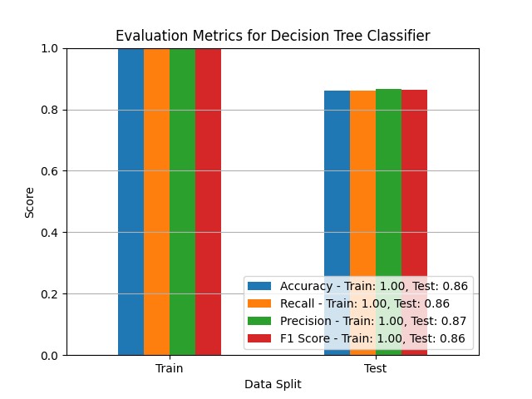

Figure 4: Decision Tree Metrics

Figure 5: Decision Tree Confusion Metric

Confusion Matrices and Random Forest Classifier Assessment Metrics:

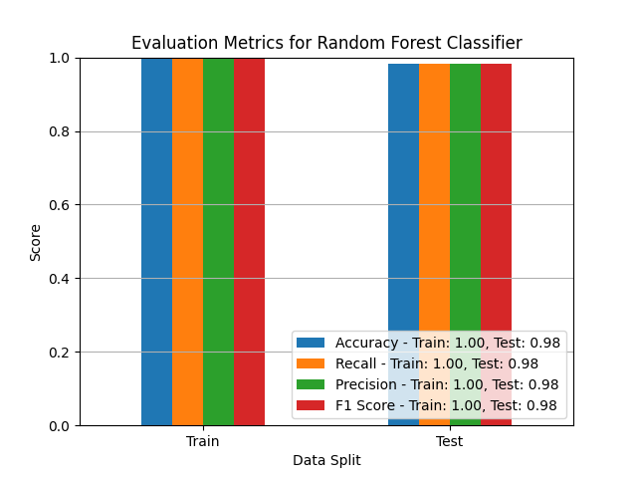

Figure 6: Random Forest Metrices

Figure 7: Random Forest Confusion Metric

These graphical displays amply demonstrate the classifiers' performance, confirming our method's efficiency in identifying the gait of people with covered bodies.

## **Discussion**

* The high performance of the Random Forest classifier can be attributed to its ensemble nature, which reduces the risk of overfitting and improves generalization.
* The experimental results demonstrate that gait recognition using machine learning is effective for identifying individuals wearing covered body attire.
* Future work should focus on further improving model performance through hyper parameter tuning and exploring additional features or alternative algorithms.
* Additionally, real-time application and scalability of the models should be investigated to enhance practical usability

# **Bibliography**

Akash Pundir, &. S. (2023). A Review of Deep Learning Approaches for Human Gait Recognition. doi:https://doi.org/10.1109/inocon57975.2023.10101267

Bhoir, A. A. (2022). Machine Learning Algorithms in Human Gait Analysis. *IGI Global EBooks*, 922–937. doi:https://doi.org/10.4018/978-1-7998-9220-5.ch053

Christopher Reining, N. R. (2023). A Tutorial on Dataset Creation for Sensor-based Human Activity Recognition. doi:10.1109/PerComWorkshops56833.2023.10150401

Liu, W. &. (2023). Gait recognition based on dynamic areas convolution. doi:https://doi.org/10.1117/12.2681338

Ma, R. Z. (2023). Gait Recognition Algorithm GCGait based on Skeleton. doi:https://doi.org/10.1109/iciba56860.2023.10165257

Narayan, V. A. (2023). Deep Learning Approaches for Human Gait Recognition: A Review. *IEEE Xplore*. doi:https://doi.org/10.1109/AISC56616.2023.10085665

Ramakrishna, M. V. (2023). Machine Learning based Gait Recognition for Human Authentication. doi:https://doi.org/10.1109/icscds56580.2023.10105085

Slemenšek, J. F. (2023). Human Gait Activity Recognition Machine Learning Methods. 745–745. doi:https://doi.org/10.3390/s23020745

Tinghuai Ma, D. J. (2018). Feature selection using forest optimization algorithm based on contribution degree. *22*(6). doi:10.3233/IDA-173636

Zhipeng Gao, J. W. (n.d.). Robust clothing-independent gait recognition using hybrid part-based gait features. *8*. doi:10.7717/peerj-cs.996